Static Timing Analysis

Homework 2

Check whether there are setup/hold violations for the given circuit. Input signal waveform and circuit parameters are given:

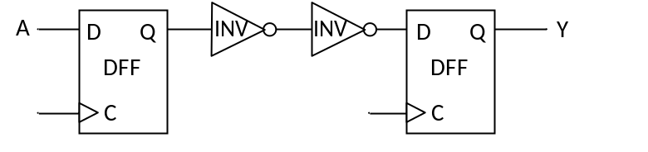

A
t(ns)
0
1.5
3.7
Parameter | Value
t_{setup,DFF} | 0.25ns
t_{hold,DFF} | 0.22ns
t_{cq,DFF} | 0.1ns
t_{INV} | 0.25ns
f_{Clock} | 333MHz

